1. MQ – CIF Creation process

Following is the status code for the CIF generation

Main application 🡪 sent to pre-booking

Borrower/Co-Borrower🡪 sent to SIBS

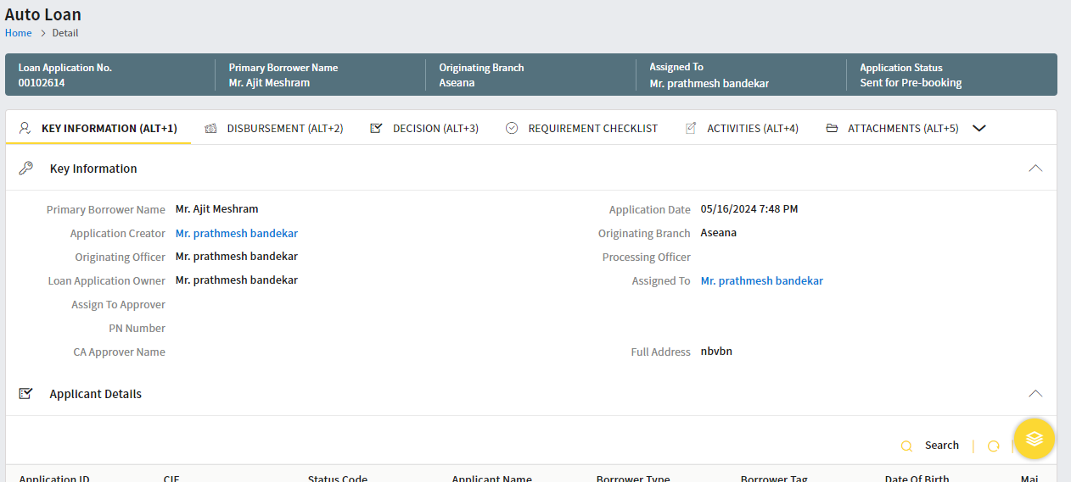

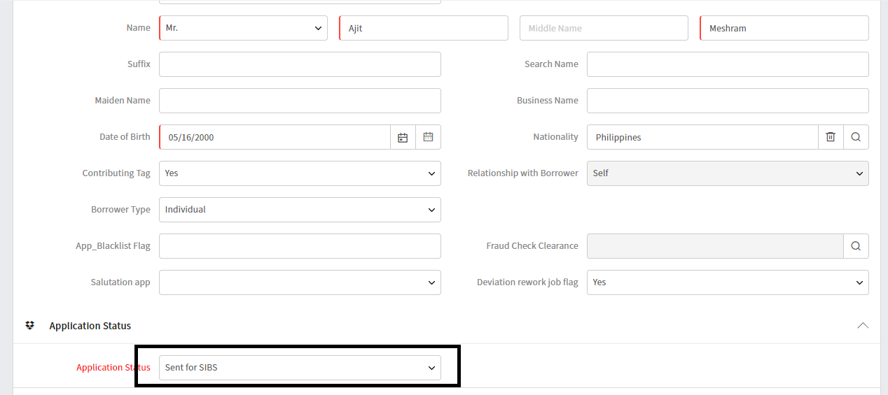

1. Following is the trigger configured and execute on save the borrower/co-borrower on sent for SIBS

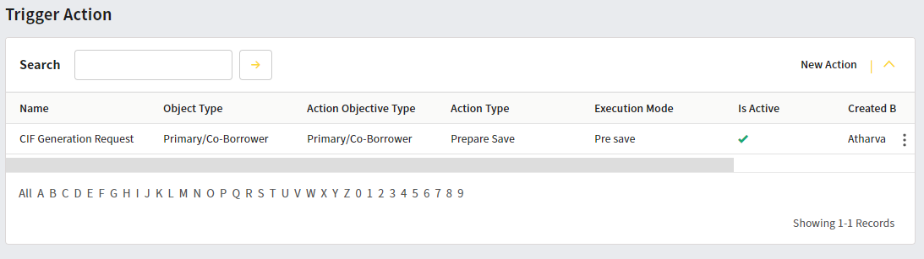

1. EDS configured to the generate the CIF request and stamp in a field

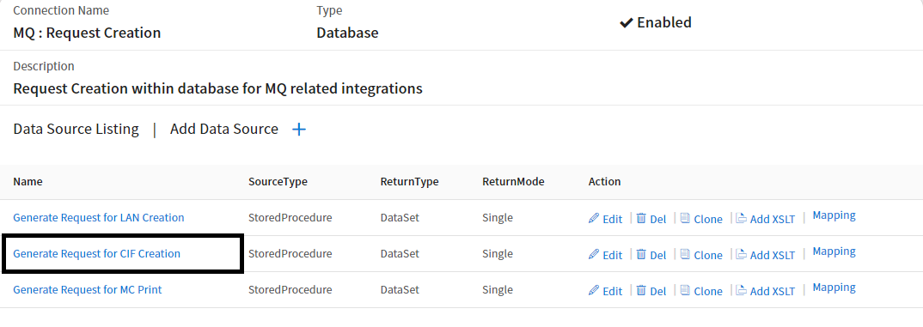

1. Trigger to configured to send the request to MQ pod

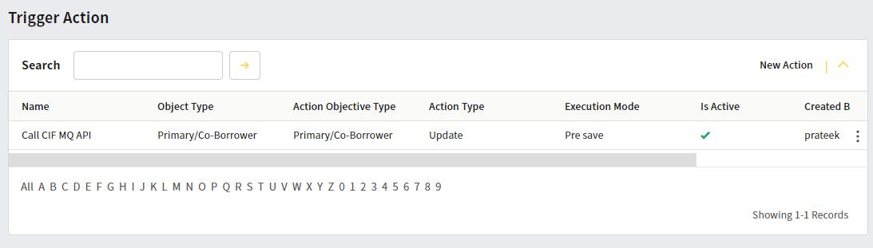

1. EDS configured to send the CIF request to IBM MQ

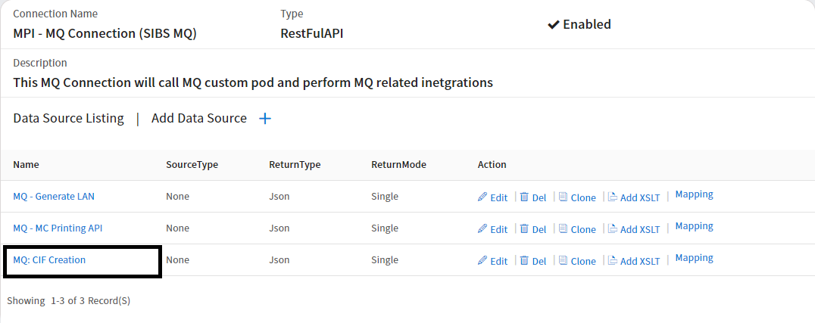

1. Generated request parser and field mapping sheet



1. Log tables

-- GENERATE REQUEST

SELECT DATEADD(MI,480,LOGGEDON)LOGTIME,* FROM EXTERNALSOURCELOG WHERE OWNERID = 985 AND DATASOURCEID=88 ORDER BY LOGGINGID DESC;

-- SEND TO MQ

SELECT DATEADD(MI,480,LOGGEDON)LOGTIME,* FROM EXTERNALSOURCELOG WHERE OWNERID = 985 AND DATASOURCEID=60 ORDER BY LOGGINGID DESC;

-- CIF GENERATION REQUEST

SELECT * FROM MPI_MQ_REQUEST_LOG WHERE REQUESTTYPE='CIF'